**CENWP-OD-B09 July 2023**

**MEMORANDUM FOR THE RECORD**

**SUBJECT: 23BON046 MFR WA Shore LPS AWS RB1 Pacific Lamprey Mortality**

On the morning of 09 July, Project Biologists discovered one adult Pacific Lamprey mortality in rest box 1 of the Washington Shore Auxiliary Water Supply LPS. (WA-LPS-AWS-RB1). The fish was scanned for PIT tags, inspected, and returned to the river.

1. Species – Pacific Lamprey (*Entosphenus tridentatus)*
2. Origin – Unknown
3. Length – 60.3 cm
4. Marks and tags – None
5. Marks and Injuries found on carcass – None
6. Cause and Time of Death – Unknown
7. Future and Preventative Measures – None

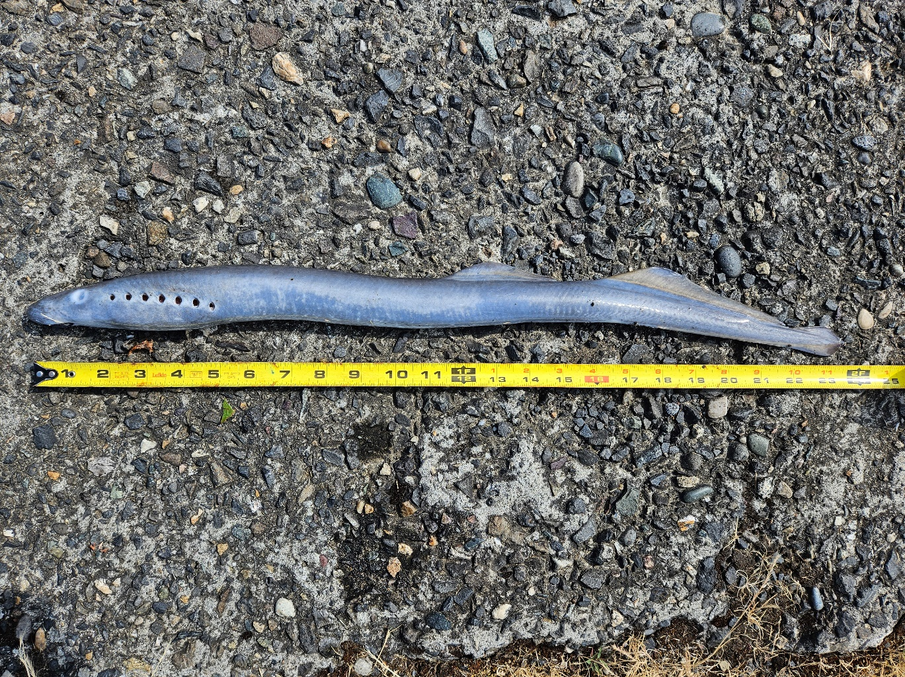

Sincerely,

Bonneville Project Fisheries